Alexander Cannell

CSIA 6210

Week 2: Getting Started

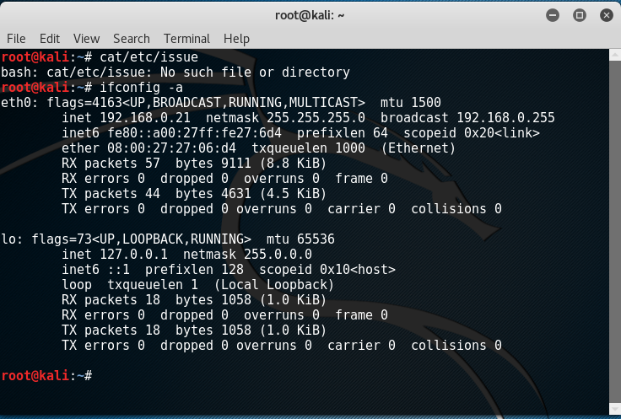

﻿

**root@kali**:**~**# cat/etc/issue  
bash: cat/etc/issue: No such file or directory  
**root@kali**:**~**# ifconfig -a  
eth0: flags=4163<UP,BROADCAST,RUNNING,MULTICAST> mtu 1500  
 inet 192.168.0.21 netmask 255.255.255.0 broadcast 192.168.0.255  
 inet6 fe80::a00:27ff:fe27:6d4 prefixlen 64 scopeid 0x20<link>  
 ether 08:00:27:27:06:d4 txqueuelen 1000 (Ethernet)  
 RX packets 57 bytes 9111 (8.8 KiB)  
 RX errors 0 dropped 0 overruns 0 frame 0  
 TX packets 44 bytes 4631 (4.5 KiB)  
 TX errors 0 dropped 0 overruns 0 carrier 0 collisions 0  
  
lo: flags=73<UP,LOOPBACK,RUNNING> mtu 65536  
 inet 127.0.0.1 netmask 255.0.0.0  
 inet6 ::1 prefixlen 128 scopeid 0x10<host>  
 loop txqueuelen 1 (Local Loopback)  
 RX packets 18 bytes 1058 (1.0 KiB)  
 RX errors 0 dropped 0 overruns 0 frame 0  
 TX packets 18 bytes 1058 (1.0 KiB)  
 TX errors 0 dropped 0 overruns 0 carrier 0 collisions 0